## References

* Azure App Service: Web Apps   
  <https://azure.microsoft.com/zh-tw/services/app-service/web/>
* Run Background tasks with WebJobs

<https://docs.microsoft.com/en-us/azure/app-service-web/web-sites-create-web-jobs>

* Create a .NET WebJob in Azure App Service

<https://docs.microsoft.com/en-us/azure/app-service-web/websites-dotnet-webjobs-sdk-get-started>

## Requirements

* Finished the part 6 of HOL
* Azure Subscription
* Visual Studio
* Device Simulator

## Goals

* Publish the web application on internet through Azure App Service.
* Add the Alarm Service Bus and Telemetry Event Processor Host projects to Azure Webjob
* Cloud deployment

## Step 1: Provision a App Services on Azure

* Provision a Web App on Azure
  + Find **App Services** in Marketplace

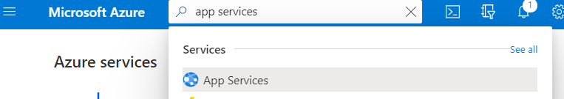

* + Configure the Web App setting
* Enter App Name
* Select Resource Group from existing
* OS: Windows
* Create new **App Service plan**

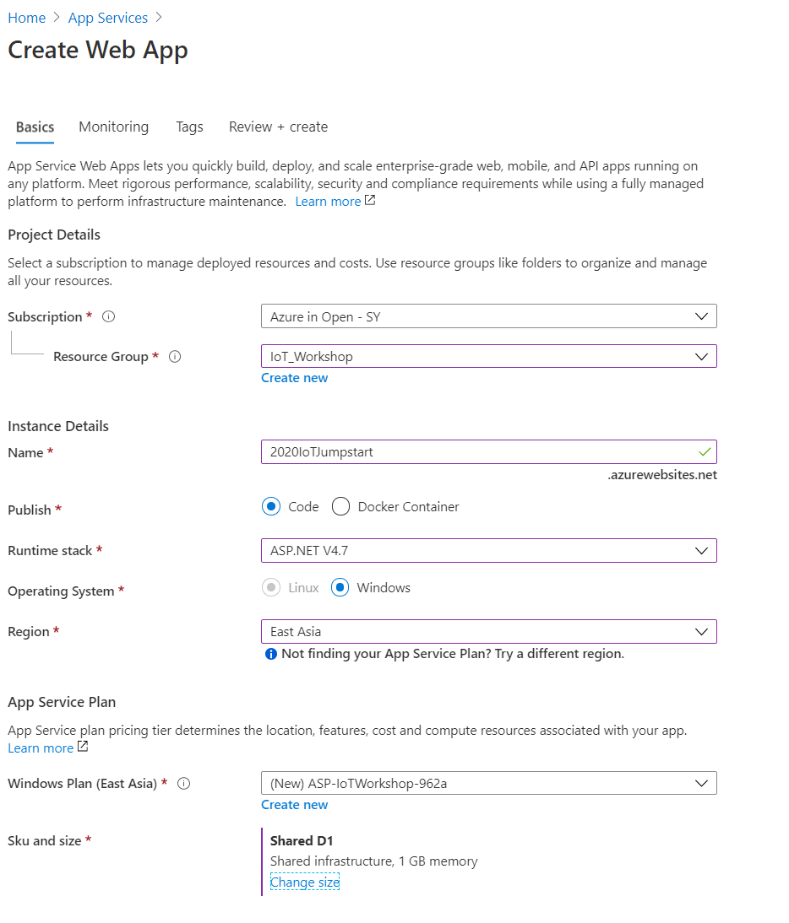

* + Add a **D1 shared** tier
    - Name your service plan
    - Select provisioned location in **East Asia**
    - Select the pricing tier as **D1 Shared**
* 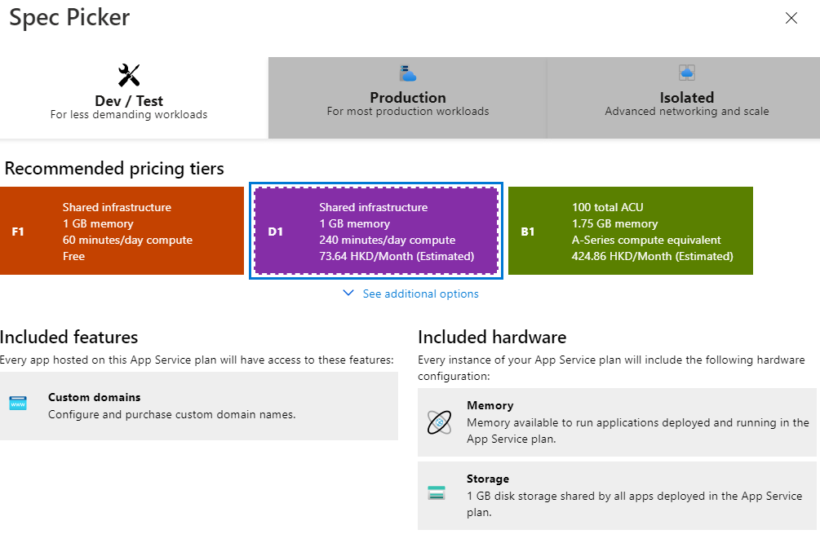
  + Select **OK >> Create** to deploy the Web App
  + Take note for the Web App Url

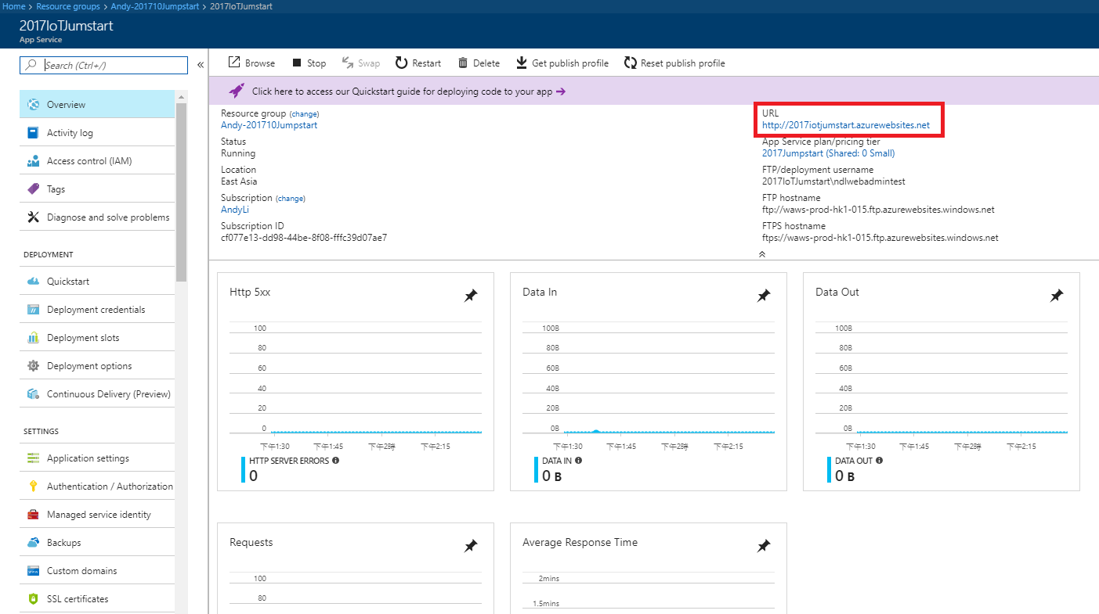

## Step 2: Publish the DahsboardSample Web App Sample on Internet

* Publish **DashboardSample** project
  + Right click DashboardSample and select **Publish**

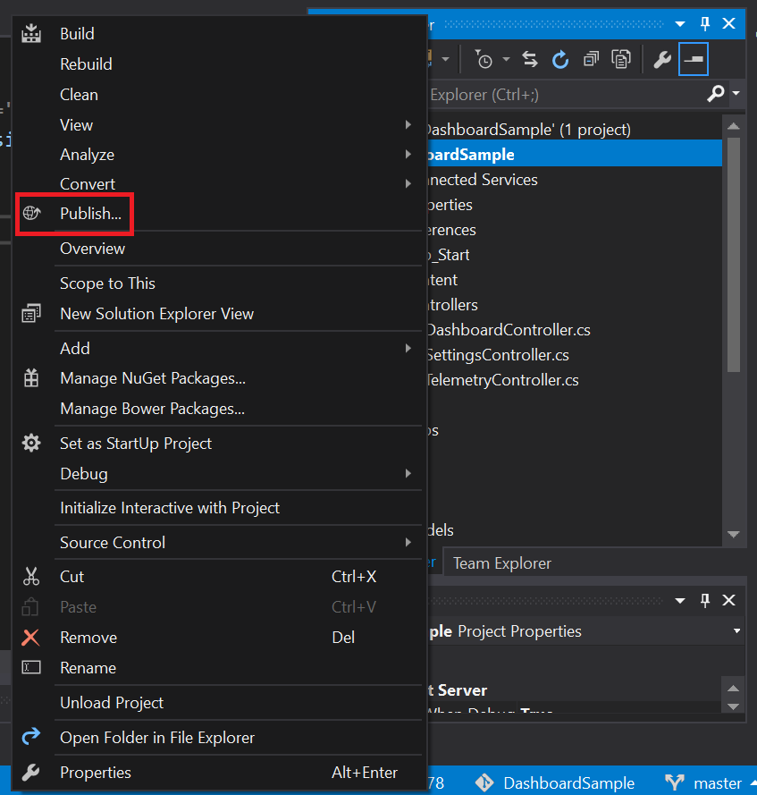

* + Select **Microsoft Azure App Service** as the publish target and **Select Existing**.

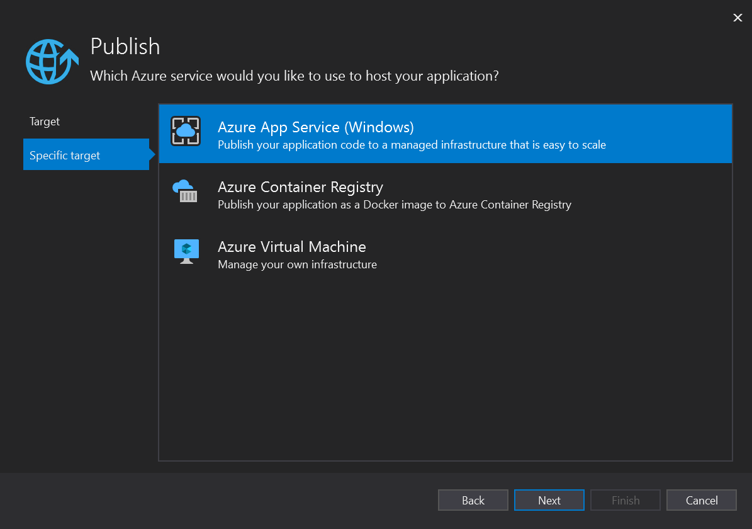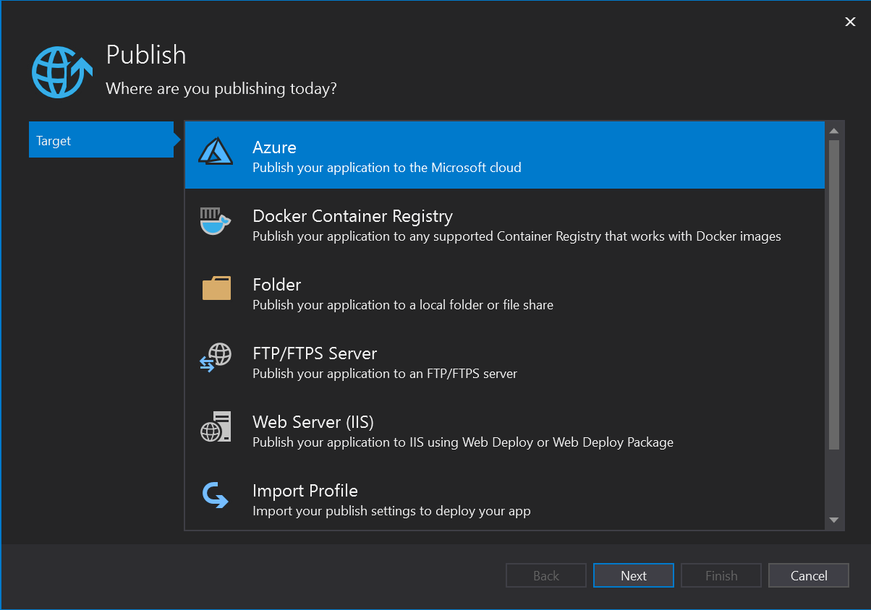

* + Openthe resource group that contains your web app

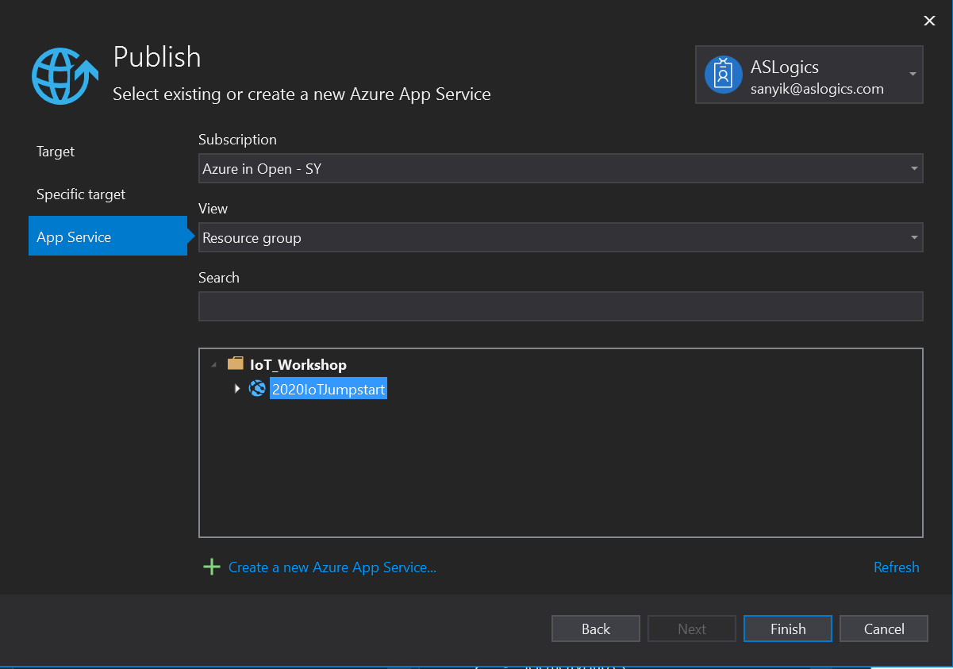

* + Publish the Web App

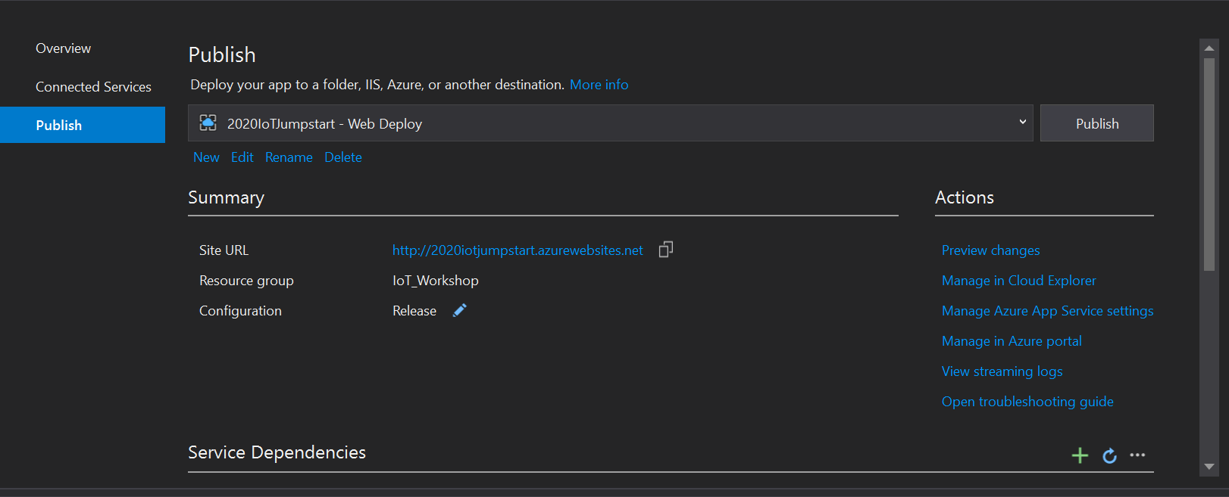

Waiting for the web publish

* + **DashboardSample** has been published on Internet

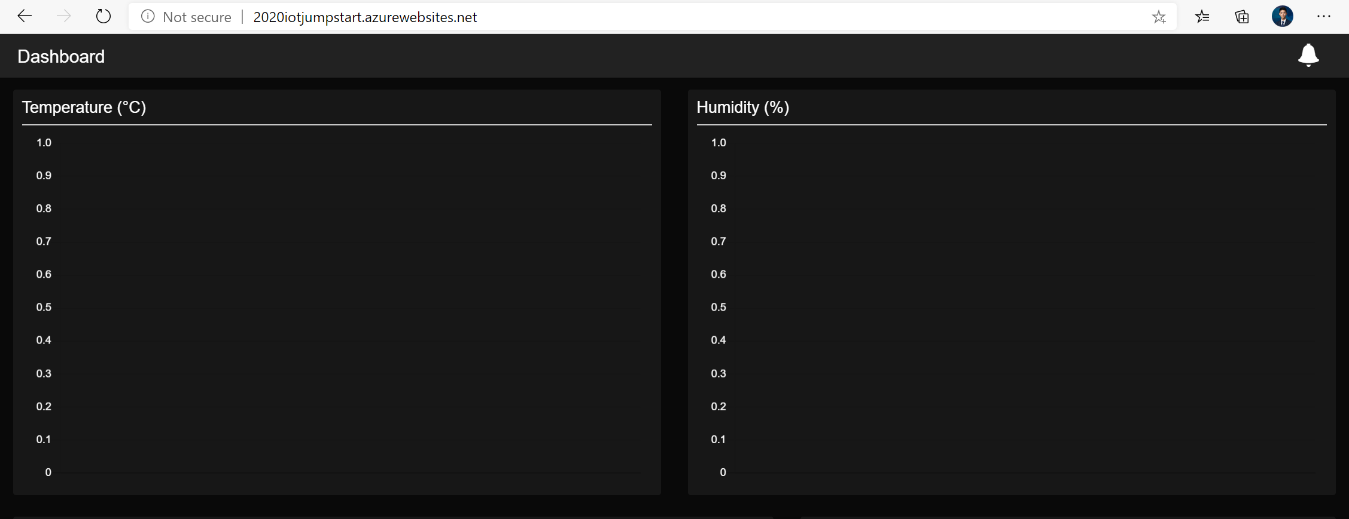

## Step 3: Publish the Alert Service Bus and Event Processor Host projects as Azure Webjob

* Update the **App.config** in **Alert Service Bus** project
  + **WebServer.isProduction**: set the value to “**1”** for production
  + **WebServer.Production**: the url of web site.

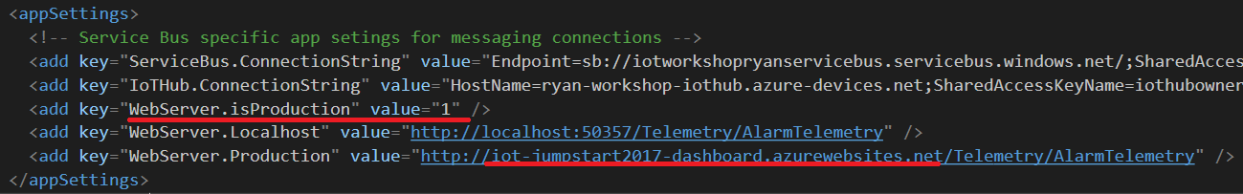

* Right-click to **Alert Service Bus** project, and Publish as **Azure WebJob**.

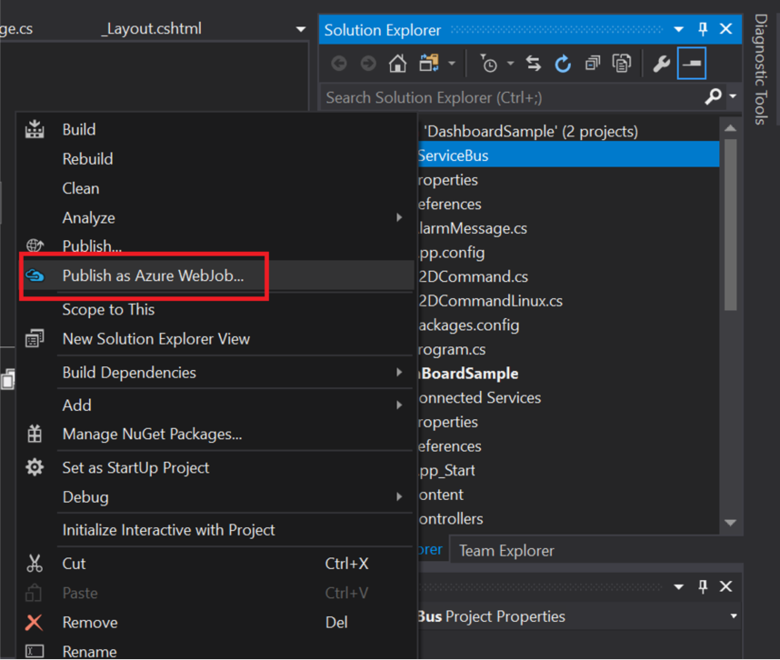

* Add Azure WebJob

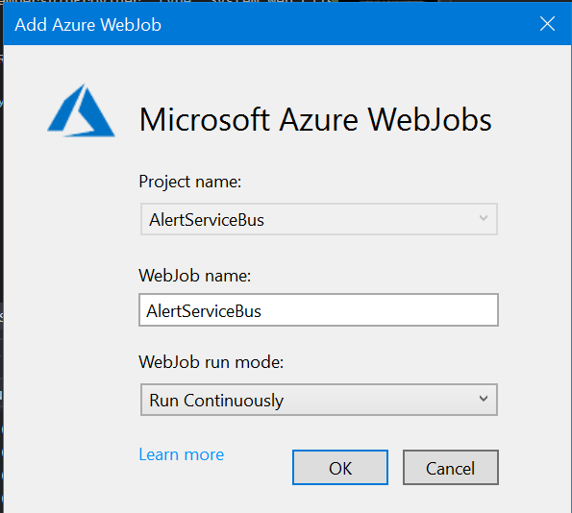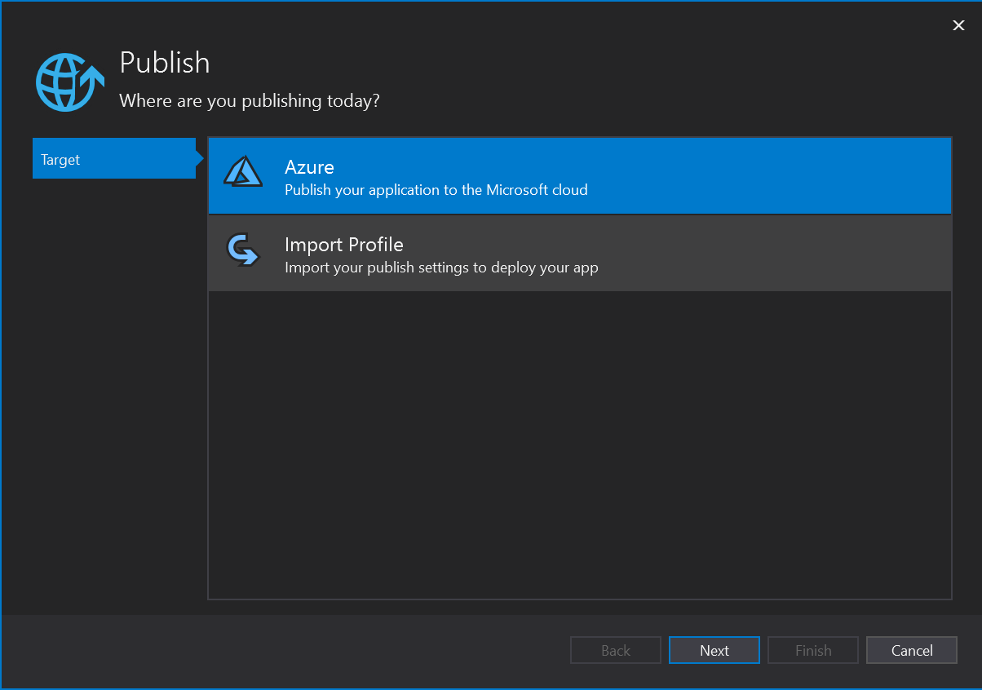

* Select the corresponded profile and resource group

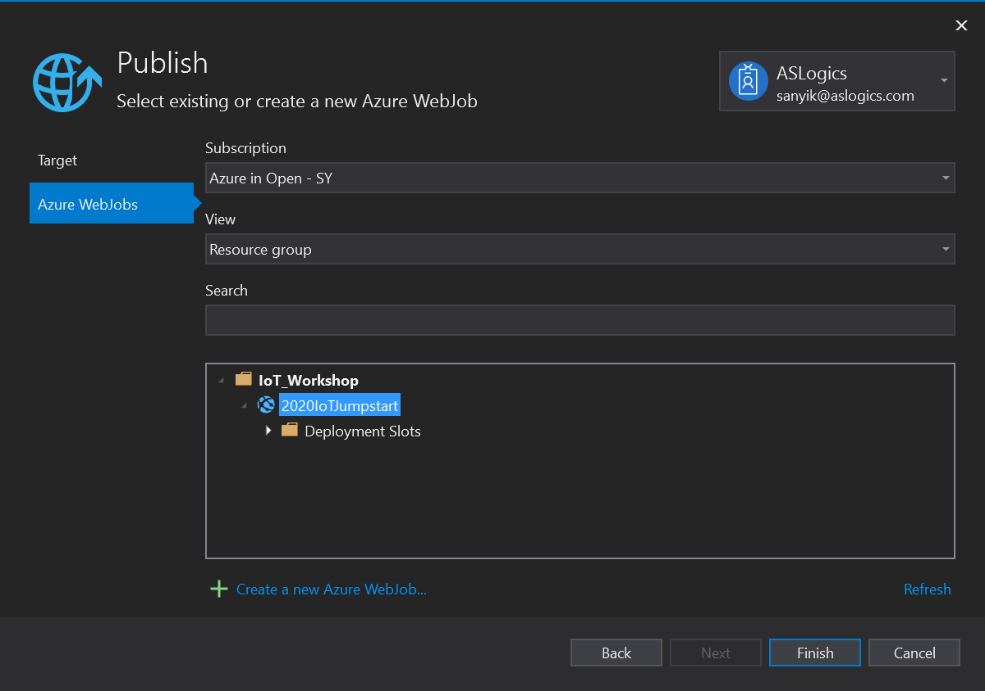

* Deploy to Azure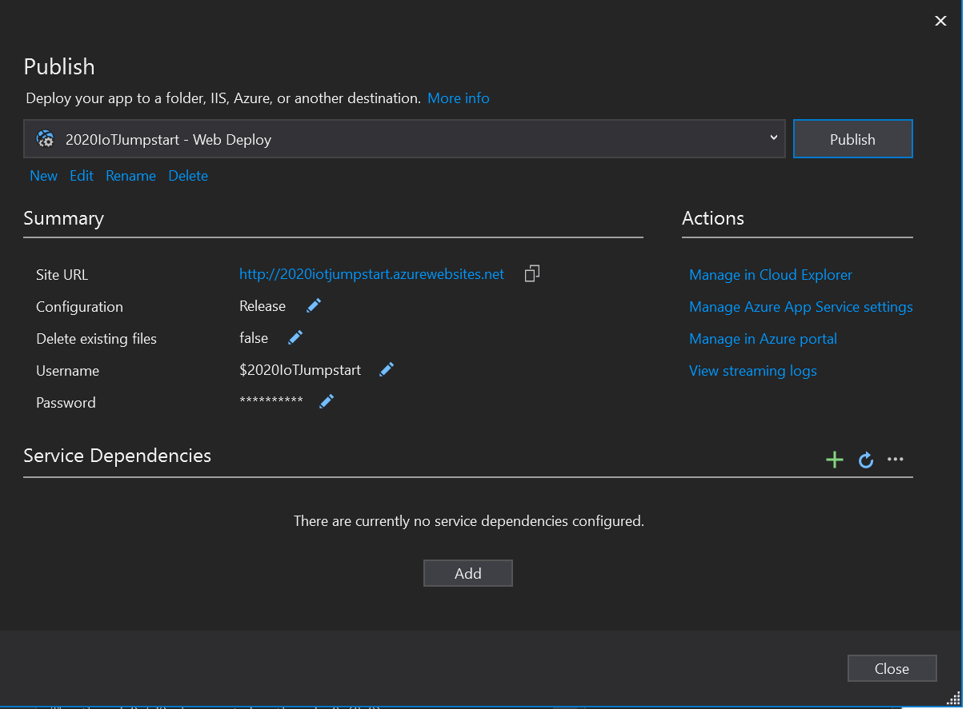
* Update the **App.config** in **TelemetryProcessor** project
* **WebServer.isProduction**: set the value to “**1”** for production
* **WebServer.Production**: the url of web site.

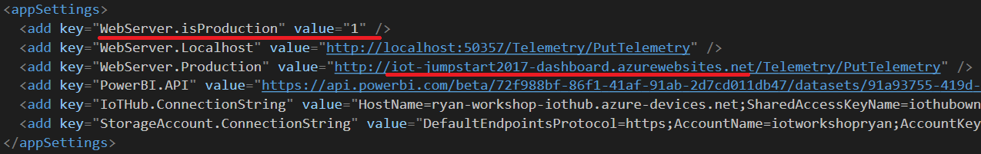

* Publish the **Telemetry Processor** as another **Azure WebJob again.**

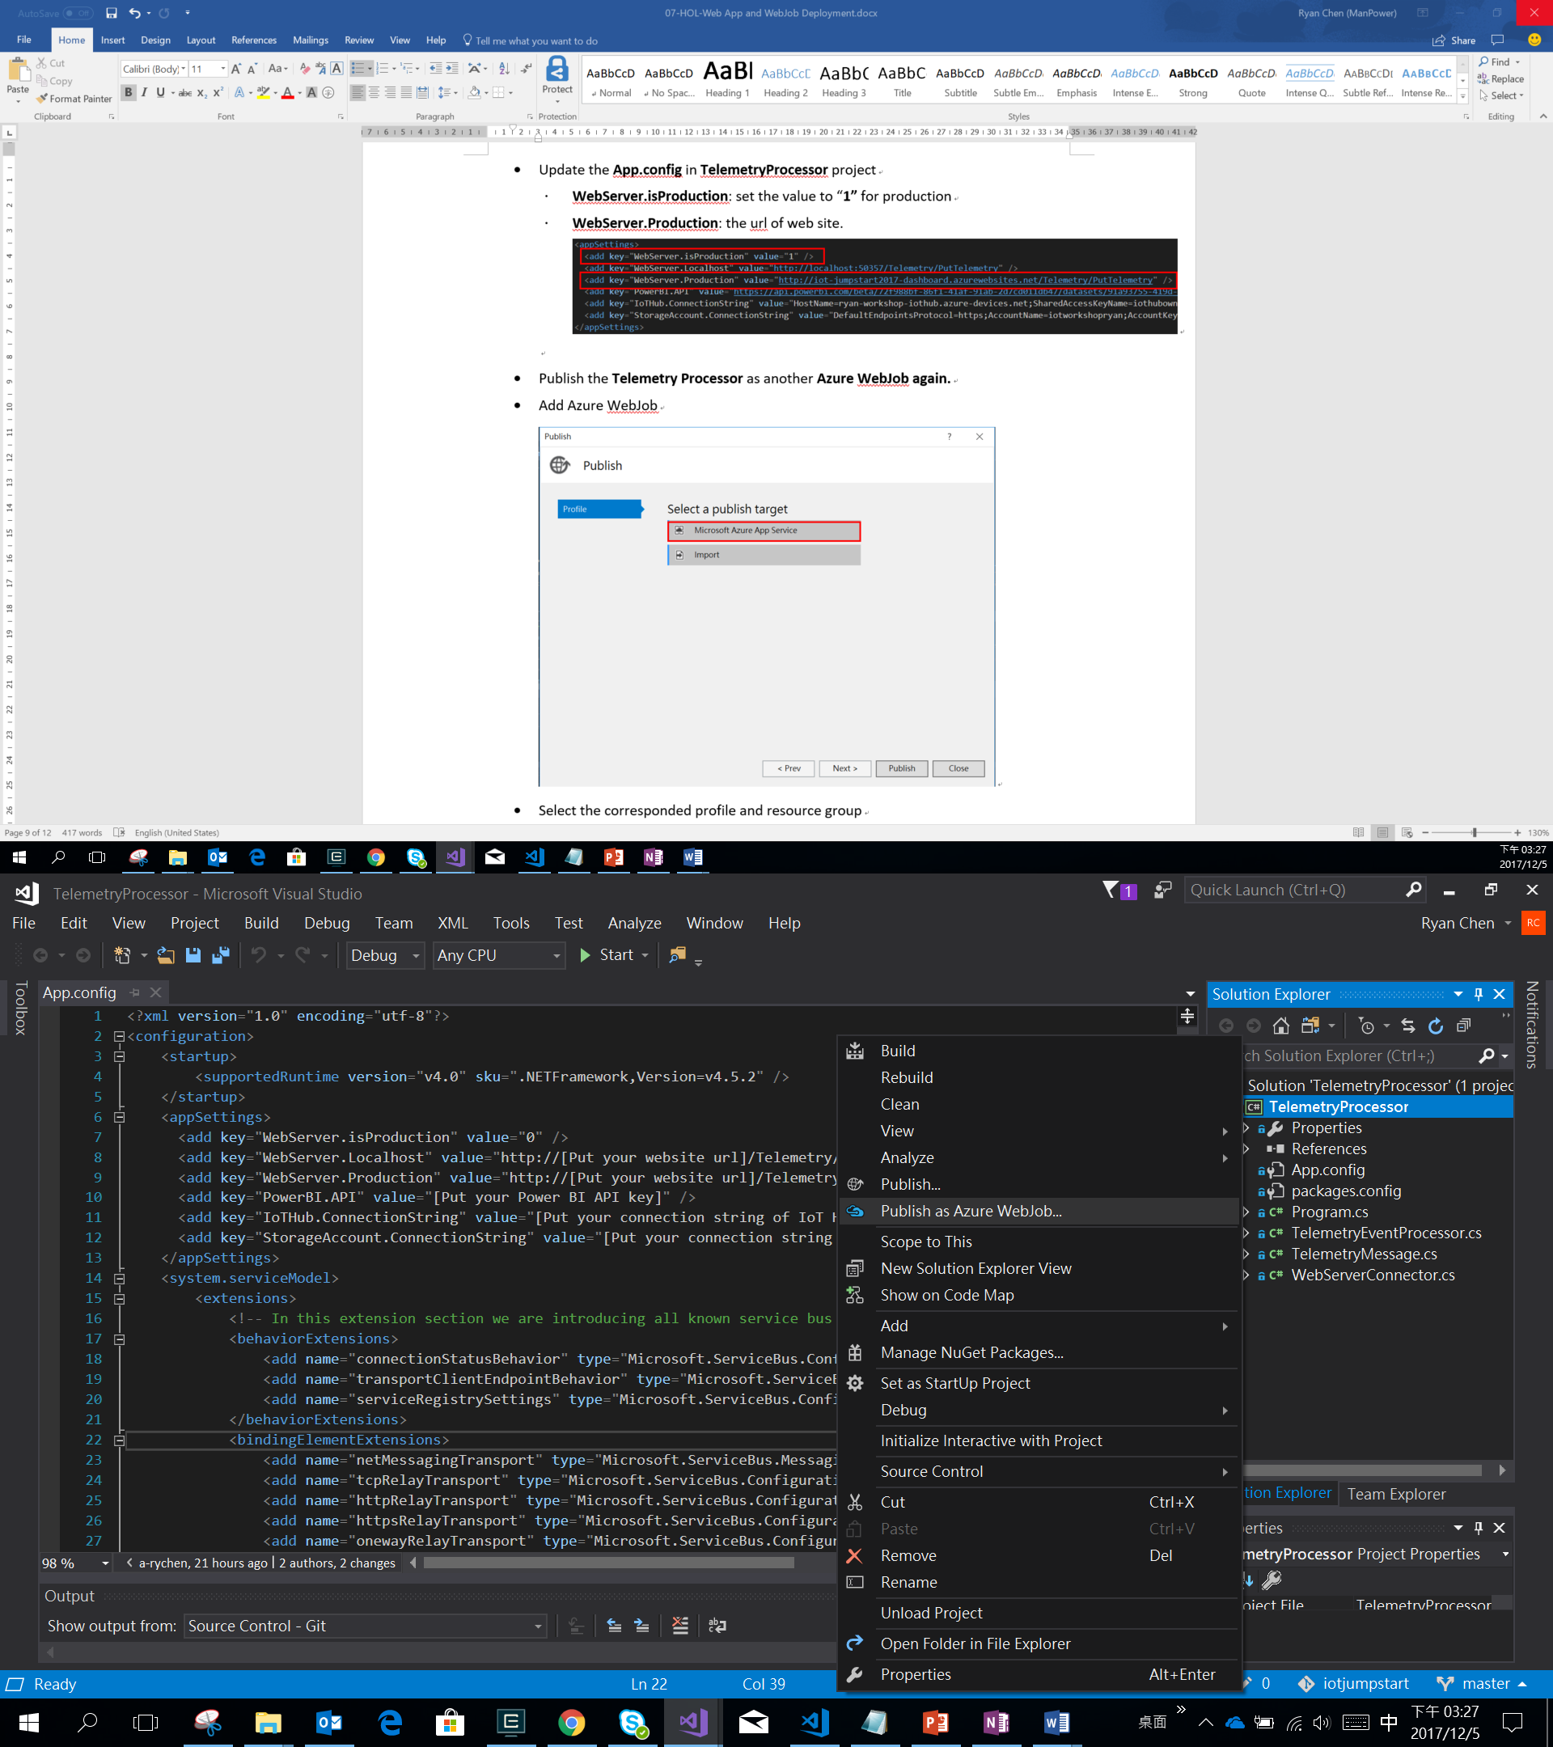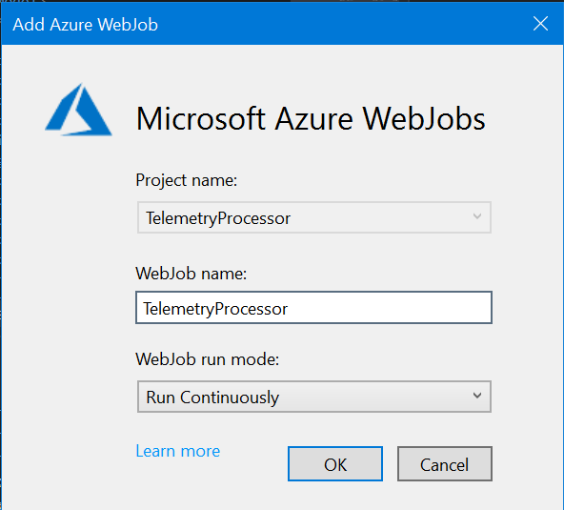

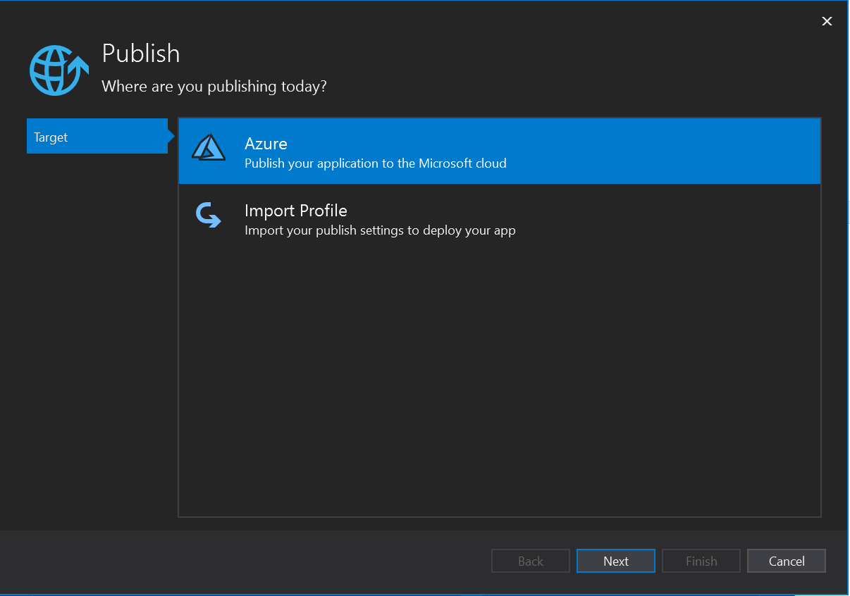

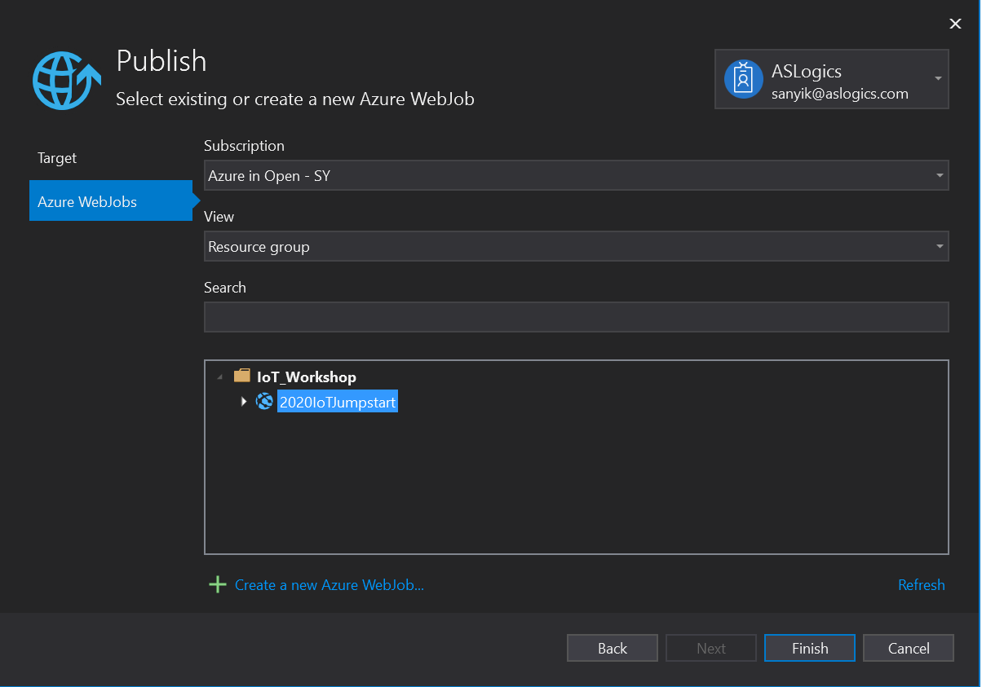

* Deploy to Azure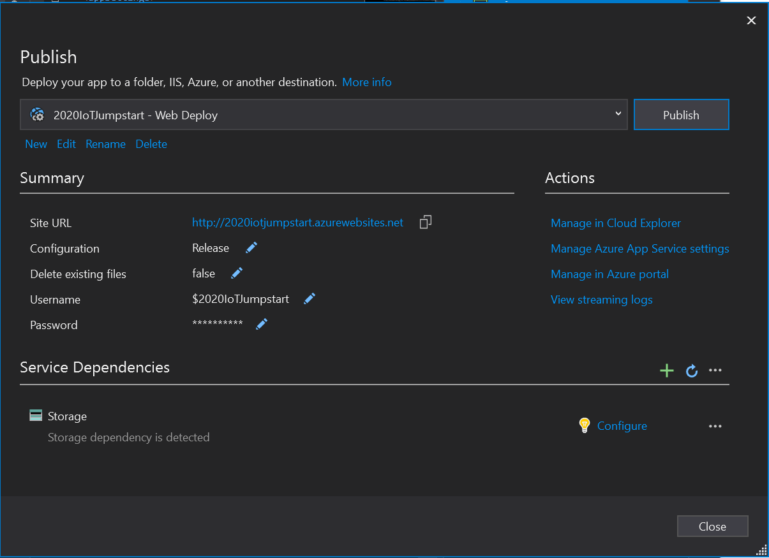
* Now the production website works well.

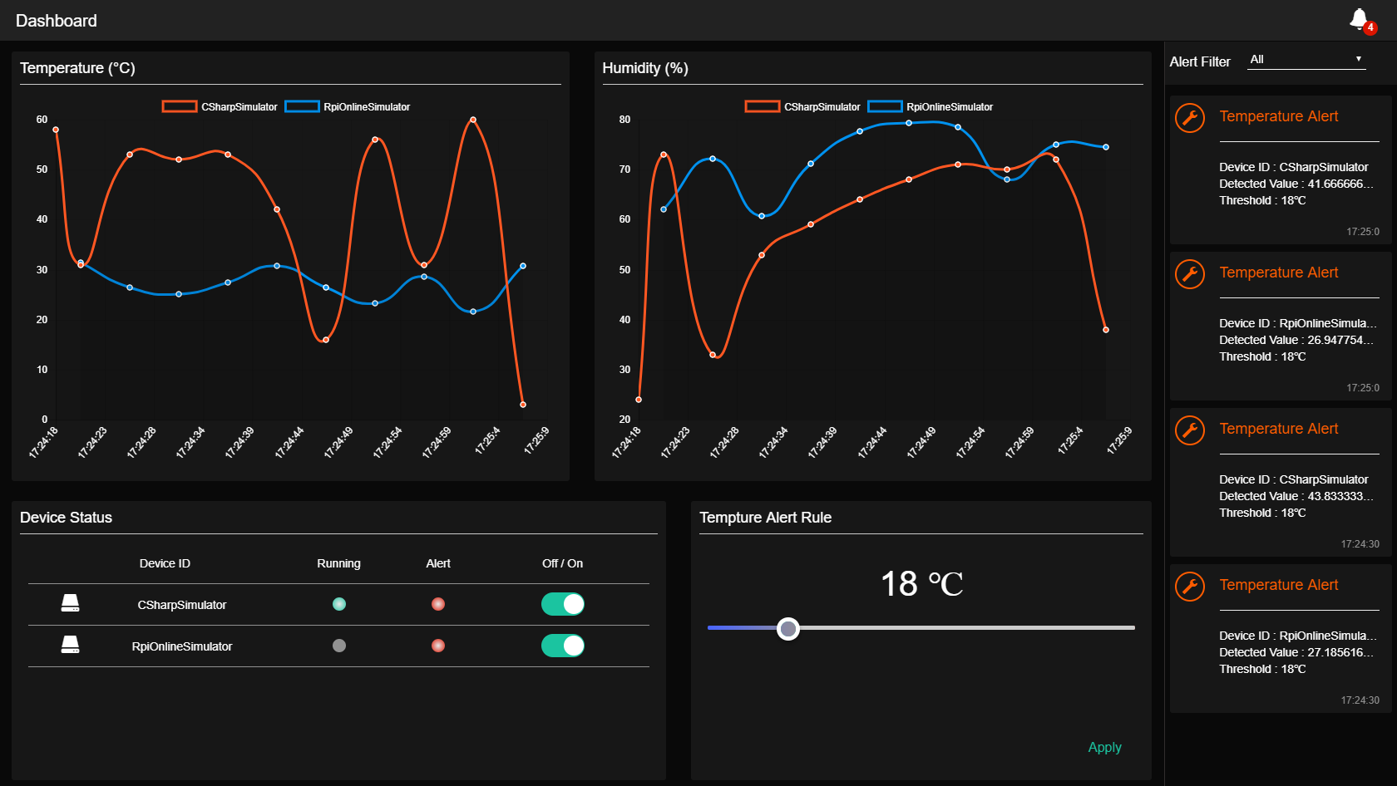

## Step 4: Watch the log of WebJob in Azure Portal

* Select the WebJob in WebApp

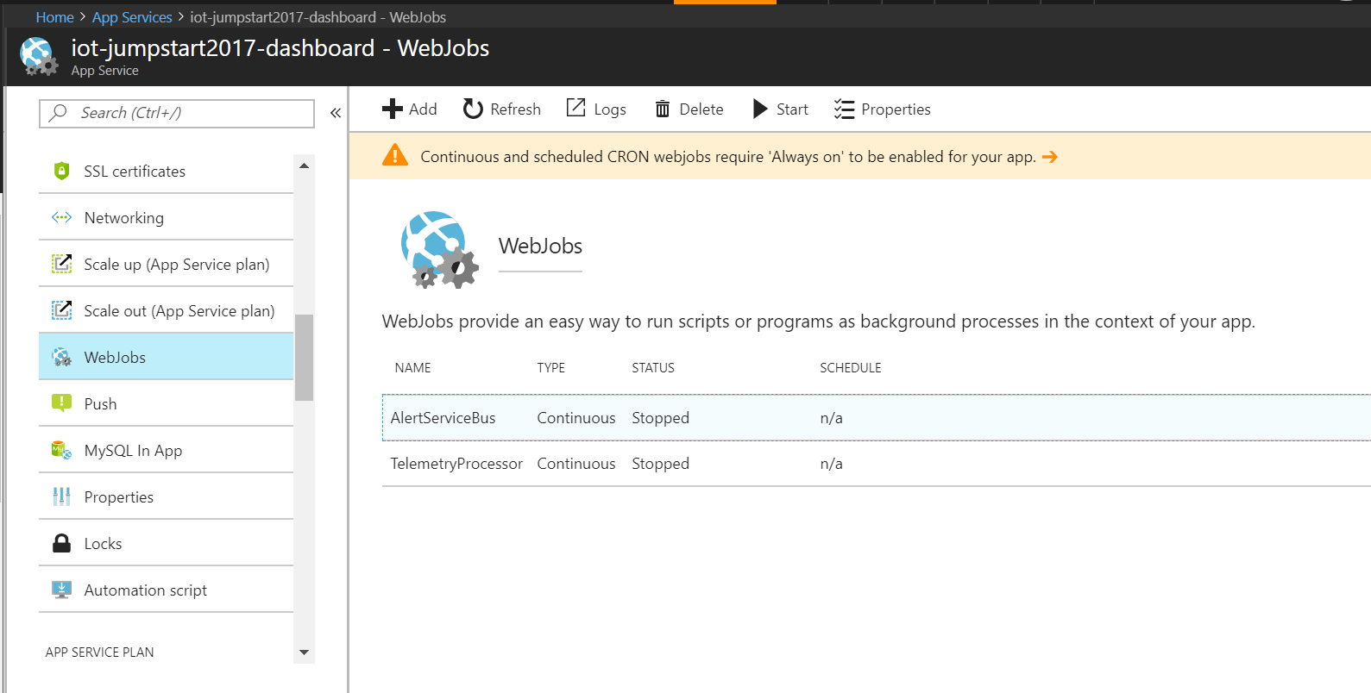

* Watch the logs of background tasks.

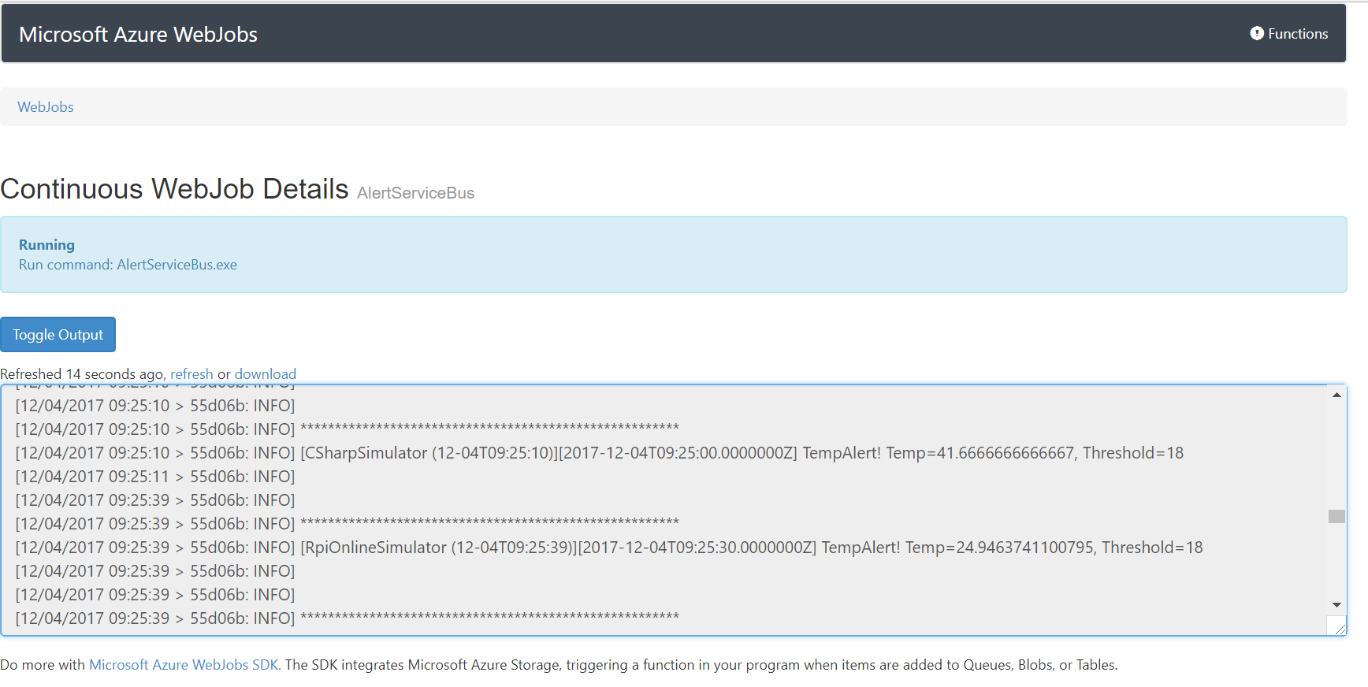

* *All HOLs has been completed. Now you have learned how to publish your web application through Azure App Service.*

*You have made great progress in the IoT world, and learned how to start the implementation of a remote monitoring solution on Azure. We hope these training materials can help you to develop your project quickly and easily.*

*Finally, Thanks for your time and it’s appreciated to get your feedback soon.*